

Course Physics
Laboratory Report

Experiment Title: Measuring the electric field strength inside a plate capacitor

Name of student: Guliyeva Aychin
Group number: CE 22.2
Team number: 07

Experiment carried out: 16 February
Lab report submitted:2 April

Supervisor: Associate Prof.G.Najafov

Synopsis
This comprehensive report provides a detailed account of the experimental procedures and result undertaken by Group- in the investigation titled “Measuring the Electric Field Strength Inside a Plate Capacitor". Thus,this report is going to explain outcomes which are derived from meticulous laboratory work and the methodical utilization of relevant equations extracted from laboratory leaflets.The main purpose of this narrative is to display what we have done in the experiment and what challenges we encountered.

Introduction
A capacitor serves as an electronic device intended for storing electrical energy within an electric field,accomplished by gathering electric charges on two closely positioned surfaces.The electric field generated within the capacitor is based on several factors,including the area of the plates ,the distance between them,and the nature of the dielectric material situated between the plates.These parameters influence the storage and electrical energy.Hence,our aim is that to assess impact of parameters on the electric field and subsequently calculate the electric energy stored within capacitor.

Theory
The magnitude of the electric field in this experiment can be determined utilizing the following formula:

E$=\frac{Q}{ε_{0}ε_{r}A}$
In this experiment,the magnitude of the electric field is determined by the charge modulus on one of the plates,plate area,the permittivity of free space,and the dielectric constant.Consequently,an alternative formula in terms of Voltage and the distance can be used to calculate the electric field.

E=$\frac{V}{d}$

With the given formula,we can calculate the electric field by employing the Voltage and specifying a particular distance for each case.Additionally,an electric field meter is integrated into the circuit ,which allows us to verify our calculations.

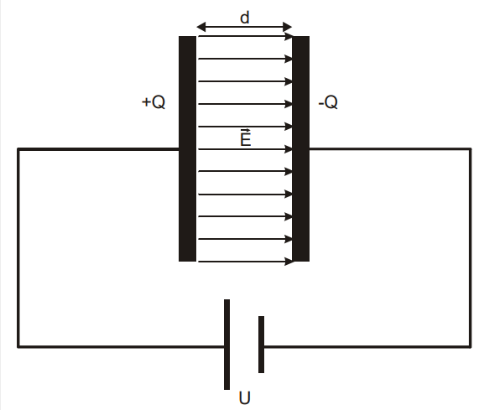

Experimental techniques
Apparatus

- 1 Electric field meter S
- 1 set of accessories for the electric field meter S
- 1 Universal measuring instrument P
- 1 high voltage power supply 10kV
- 2 Clamp riders with clamp 45/35
- 1 Optical bench, S1 profile, 50cm
- 1 Safety connection lead, 10cm, yellow/green
- 1 safety connection lead, 100cm, red
- 1 safety connection lead, 100cm, blue

Setup and carring out the experiment:
Setup:
Secure one capacitor plate firmly by attaching it to a stand base using a plastic rod and clamp on the optical bench profile S1. Then, place the drilled capacitor plate onto the electric field meter S, ensuring it's securely attached with clamps on the optical bench profile S1. Connect the electric field meter to the universal measuring instrument P for gathering data.

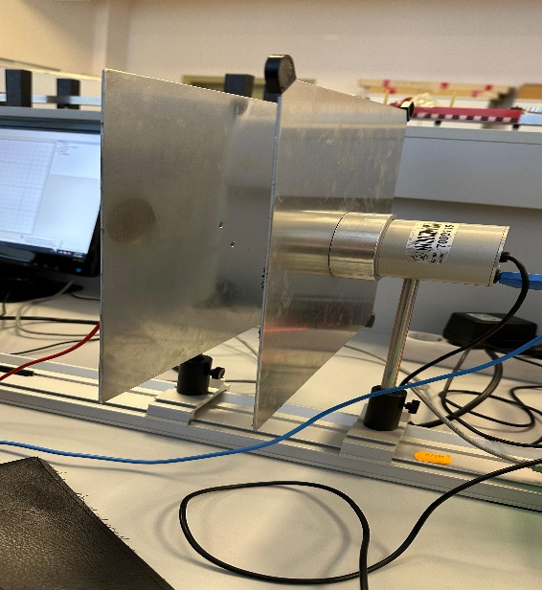

Carrying out:
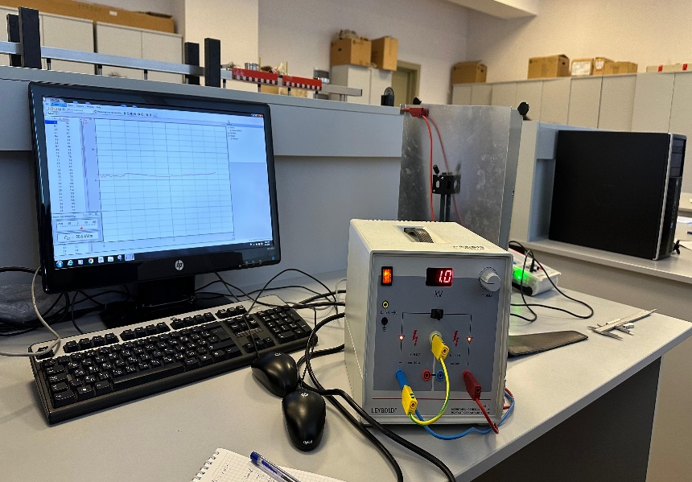
Utilize a measuring instrument to calculate the distance between the plates.Proceed to replicate this sequence for various values of ”d” to obtain a range of data for analysis.
Results-Experimental and derived
Following the provided instructions, the experiment was conducted, and the resulting data was recorded in the corresponding table.

d(mm) | 4 | 7 | 10 | 13 | 16
E(device)  (kv/m) | 82.7 | 54.4 | 48.6 | 41.4 | 27.3
E(calculated)  (kv/m) | 250 | 142,8 | 100 | 76,9 | 62.5

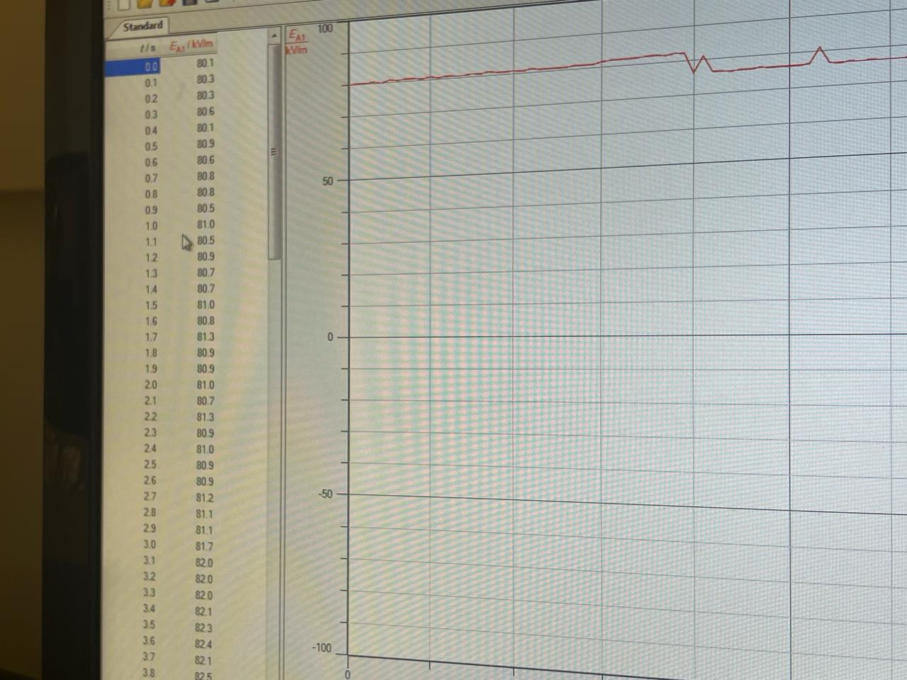
Discussion of result
The outcomes obtained from both experimental and calculated approaches show coherence,although they may not produce exact matches.In each test,electric field was computed with formula and data obtained from electric field measuring device.It is evident that fluctuation occurred during our experiment.Furthermore,cause of errors is that potential inaccuracies in the distance measuring instrument,slight deviations in the parallel alignment of plates,and other minor variables,including environmental factors such as room conditions.

Conclusion
This laboratory experiment has carried out for determining the electric field within a plate capacitor.Although some errors were encountered,the main goal of our laboratory work was successfully achieved.All differences were added to the Table 1.

Refference
Laboratory leaflets,example which was provided by laboratory instructor.

